**WEMOS Lolin Relay Shield**

**https://forum.hobbycomponents.com/viewtopic.php?f=111&t=2127**

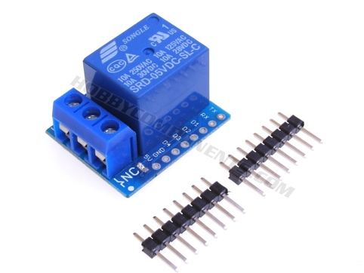

This relay shield is designed to be used with the WeMos mini & mini Pro ESP8266 based development boards (see item HCWEMO0002). Adding this shield to your WeMos mini development board provides it with the ability to switch high voltage, or high power devices from a single digital pin. Included with the shield is a set of header pins which can be optionally fitted (soldering required) to allow for the shield to be easily inserted and removed from the D1 mini.

Although this module is intended for use with the Wemos development boards it can of course also be used as a standalone relay module requiring a single 5V supply and one digital pin (5V & 3.3V compatible) to control it.

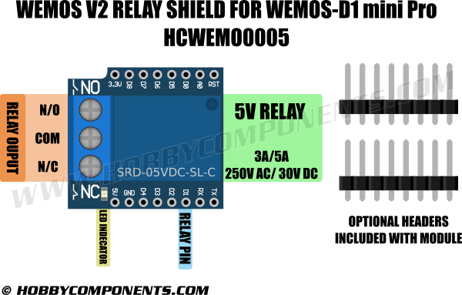  
  
NO: 5A(250VAC/30VDC), 10A(125VAC), MAX:1250VA/150W  
NC: 3A(250VAC/30VDC), MAX:750VA/90W

*/* WeMos relay example - HobbyComponents.com */*

*#include <ESP8266WiFi.h>*

*#define PIN D1 // Relay shield is controlled by digital pin D1*

*void setup()*

*{*

*pinMode(PIN, OUTPUT); // Set the pin to an output*

*}*

*void loop()*

*{*

*digitalWrite(PIN, HIGH); // Energise the relay*

*delay(1000); // Wait for another second*

*digitalWrite(PIN, LOW); // De-energise the relay*

*delay(1000); // Wait for a second*

*}*

# D1 mini

A mini wifi board with 4MB flash based on ESP-8266EX.

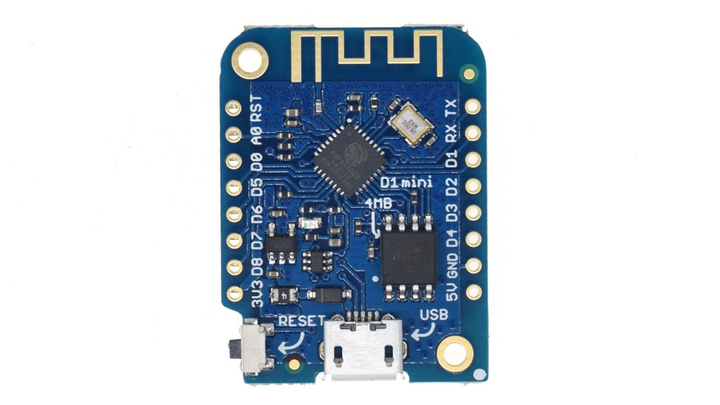

## Features

* 11 digital input/output pins, all pins have interrupt/pwm/I2C/one-wire supported(except D0)
* 1 analog input(3.2V max input)
* a Micro USB connection
* Compatible with MicroPython, Arduino, nodemcu

## Tutorials

* [Get started in Arduino](https://wiki.wemos.cc/tutorials:get_started:get_started_in_arduino)
* [Get started in NodeMCU](https://wiki.wemos.cc/tutorials:get_started:get_started_in_nodemcu)
* [Revert to the Factory Firmware (AT)](https://wiki.wemos.cc/tutorials:get_started:revert_to_at_firmware)

## Documentation

* [Schematic V3.0.0](https://wiki.wemos.cc/_media/products:d1:sch_d1_mini_v3.0.0.pdf)
* [Driver](https://wiki.wemos.cc/downloads) https://wiki.wemos.cc/downloads

| **Microcontroller** | **ESP-8266EX** |
| --- | --- |
| Operating Voltage | 3.3V |
| Digital I/O Pins | 11 |
| Analog Input Pins | 1(Max input: 3.2V) |
| Clock Speed | 80MHz/160MHz |
| Flash | 4M bytes |
| Length | 34.2mm |
| Width | 25.6mm |
| Weight | 3g |

## Pin

| **Pin** | **Function** | **ESP-8266 Pin** |
| --- | --- | --- |
| TX | TXD | TXD |
| RX | RXD | RXD |
| A0 | Analog input, max 3.3V input | A0 |
| D0 | IO | GPIO16 |
| D1 | IO, SCL | GPIO5 |
| D2 | IO, SDA | GPIO4 |
| D3 | IO, 10k Pull-up | GPIO0 |
| D4 | IO, 10k Pull-up, BUILTIN_LED | GPIO2 |
| D5 | IO, SCK | GPIO14 |
| D6 | IO, MISO | GPIO12 |
| D7 | IO, MOSI | GPIO13 |
| D8 | IO, 10k Pull-down, SS | GPIO15 |
| G | Ground | GND |
| 5V | 5V | - |
| 3V3 | 3.3V | 3.3V |
| RST | Reset | RST |

All of the IO pins have interrupt/pwm/I2C/one-wire support except D0.

All of the IO pins run at 3.3V.

## Requirements

* [CH340G](https://wiki.wemos.cc/downloads) driver(for [D1](https://wiki.wemos.cc/products:d1:d1)/[D1 mini](https://wiki.wemos.cc/products:d1:d1_mini)/[D1 mini Lite](https://wiki.wemos.cc/products:d1:d1_mini_lite))
* [CP2104](https://www.silabs.com/products/mcu/Pages/USBtoUARTBridgeVCPDrivers.aspx) driver(for [D1 mini Pro](https://wiki.wemos.cc/products:d1:d1_mini_pro))

## Installing Hardware package

<https://github.com/esp8266/Arduino>

## Configure Board

After install hardware package, you will see WEMOS boards

in the Tools→Board:xxx Choose your right board.